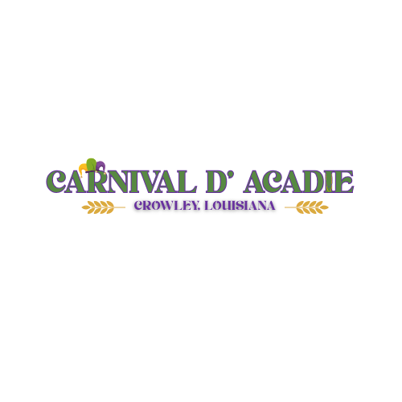

Tuesday, February 17, 2026
10:00 AM

Parade Entry Form

Name organization/group: _______________________________________________________________________

Contact person: _______________________________________________________________________

Address: _______________________________________________________________________

Phone #: _______________________

Email: ___________________________________________________

Description of Entry (check one):
_________Political
__________School
_________Business
__________Non-profit
__________ Other

(Describe)_______________________________________________________________________

Entry Fee (check one)

__________$20 _______$15 ____________ $35
Single vehicle/School entries/ Golf Cart/Side by Side Float (Single vehicle pulling)
Dance troupes

Make checks payable to: Crowley Community Development
P. O. Box 1463
Crowley, LA 70527-1463

Parade Safety Policy:

Signed Parade Agreement with entry fee must be received by Friday, February 13, 2026, during business hours. A copy of driver’s license and vehicle insurance must accompany all entries. Driver’s license and insurance will be verified on the day of parade.

Parade begins at 10:00 a.m.
Line up begins 8:00 a.m. south of the railroad track.
NO glass containers are allowed.
All minor children must be accompanied and supervised by an adult.

All throws must be limited to wrapped candy, Mardi Gras beads, and doubloons. No live, sharp, or sexually explicit throws will be permitted.
All throws must be thrown from the side-to-side, 10 - 12' away from float. Nothing may be thrown unless the parade is moving, nor can they be handed to anyone approaching the float or vehicle.
Riders must always keep arms and legs inside the float.
Drivers must proceed with caution and at a safe speed keeping one-car length behind the vehicle ahead of them. All vehicles must follow state and local laws concerning traffic and alcoholic beverages for the safety of all.

POSITIVELY NO DRINKING BY THE DRIVER!!!

Please note: All horse waste must be picked up and properly disposed of.
As this is a family-friendly event, your behavior, language, and the music you select must be appropriate, otherwise, security will ask you to leave the premises.

Any unit not complying with these safety policies will be removed without refund!!!

