
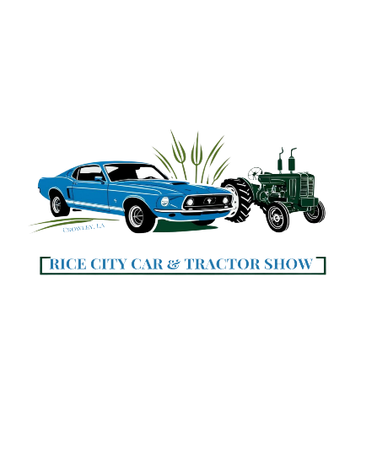

Car Registration Form

Saturday April 18, 2026, 9:00am to 3:00pm
Historic Main Street, Parkerson Avenue
Crowley, Louisiana
SCAN TO
Register & Pay
ONLINE!

Registration $20.00 Early Registration Deadline: April 3, 2026
Return Form to Crowley City Hall, 425 North Parkerson Ave.
Mail Form: Crowley City Hall, Attention: Val Myers

P O Box 1463, Crowley, LA 70527-1463
Reserved Parking Participant
First 30 Early Registration Entries receive a goodie bag.
RC Car Show - make check or money orders payable to: Crowley Community Development Assoc.
For Registration Info contact: Mike Libby: 337.458.0682
Val Myers: 337.783.0824 or valerie.myers@crowley-la.com

Please Print | Date:
Name
 | First Last
Mailing Address
 | City State Zip
E-Mail Address
Phone #’s | Home ( ) cell ( )
#1 Vehicle Info | Year: Make / Model:
#2 Vehicle Info | Year: Make / Model:

Liability Release: In consideration of acceptance as a participator or spectator of the above mentioned Events, I do hereby release and discharge The City of Crowley, its officers, members and all others involved in the presentation of the 2026 Rice City Car Show and the 2026 Rice City Antique Tractor & Implement Show including the City of Crowley, Louisiana, Acadia Parish and its administration and employees and all participating businesses, owners and representatives of any property and or spectators including the conduct of any entrant or spectator.
No Refunds due to cancellation of inclement weather or unforeseen circumstances.

Participant/Entrant Signature: X_____________________________________ Date ________________
ALL Registration Forms Must be Signed mm / dd / yy

Office Use | Check # | Check $ | Cash $ | Date / / 2026
Please Initial | Received by: |  | Deposited by: | Date / / 2026

www.crowley-la.com

Proceeds to benefit the Crowley Community Development Association.



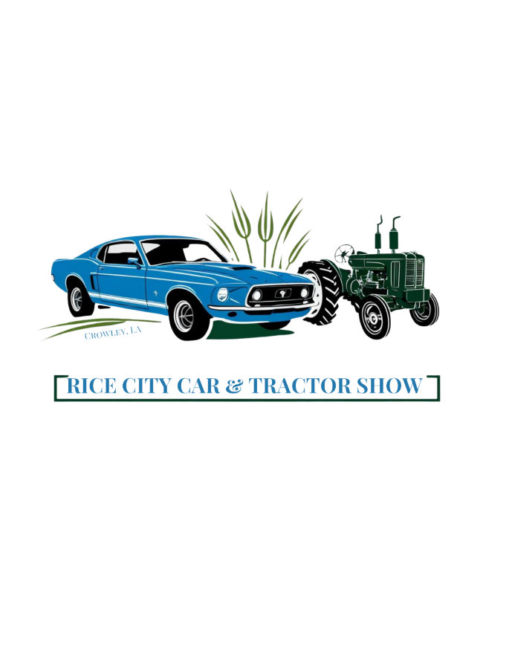

Tractor Registration Form
Saturday April 18, 2026, 9:00am to 3:00pm

Historic Main Street, Parkerson Avenue
Crowley, Louisiana

Registration $20.00 Early Registration Deadline: April 3, 2026
Return Form to Crowley City Hall, 425 North Parkerson Ave
Mail Form: Crowley City Hall, Attention: Val Myers
P O Box 1463, Crowley, LA 70527-1463
Reserved Participant Parking
First 5 Registration Entries receive a goodie bag.
RC Tractor Show - make check or money orders payable to: Crowley Community Development Assoc.

For Registration Info contact: Mike Libby: 337.458.0682 or Corey Faulk: 337.458-0775
Val Myers 337.783.0824 or valerie.myers@crowley-la.com

Please Print | Date:
Name
 | First Last
Mailing Address
 | City State Zip
E-Mail Address
Contact Phone #’s | Home ( ) cell ( )

# | Year | Equipment – Description (make & model) | Implement Description (make & model) | R # Office use
1
2
3
4
5

Liability Release: In consideration of acceptance as a participator or spectator of the above mentioned Events, I do hereby release and discharge The City of Crowley, its officers, members and all others involved in the presentation of the 2026 Rice City Car Show and the 2026 Rice City Antique Tractor & Implement Show including the City of Crowley, Louisiana, Acadia Parish and its administration and employees and all participating businesses, owners and representatives of any property and or spectators including the conduct of any entrant or spectator.
No Refunds due to cancellation of inclement weather or unforeseen circumstances.

Participant/Entrant Signature: X_____________________________________ Date ________________
ALL Registration Forms Must be Signed mm / dd / yy

Office Use | Check # | Check $ | Cash $ | Date / / 2026
Please Initial | Received by: |  | Deposited by: | Date / / 2026

www.crowley-la.com

Proceeds to benefit the Crowley Community Development Association.

